**User Manual of Case Description**

**There are three forms in Case Description –**

1. **Case List form:**

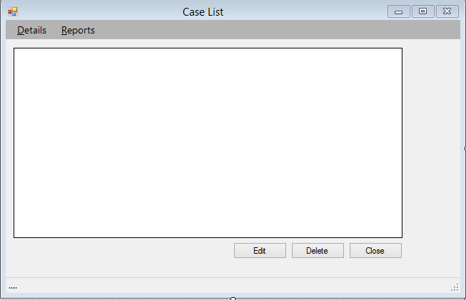

* **This is Case List Form through which advocate view, edit and delete the lists of details and reports.**
* **Details and Reports tabs include lists of hearing dates, witnesses, payments and documents.**

1. **Case Types Form:**

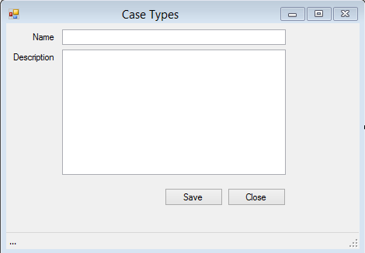

* **This is Case Types form in which the advocate can store information about various cases.**

1. **Case Types List Form:**

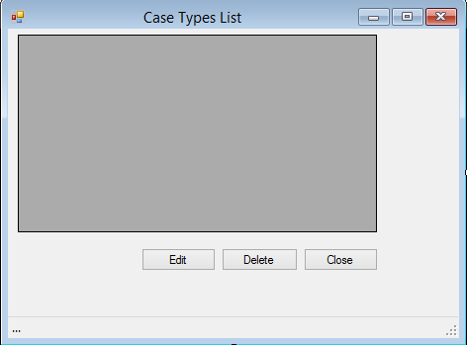

* **This is Case Types List Form through which advocate can view, edit and delete the lists of case types.**